CHAPTER: 9
SNAPSHOT OF WEBSITE

Admin Side

Participant Side

Organizer Side

Judge Side

Admin Side

Admin login:

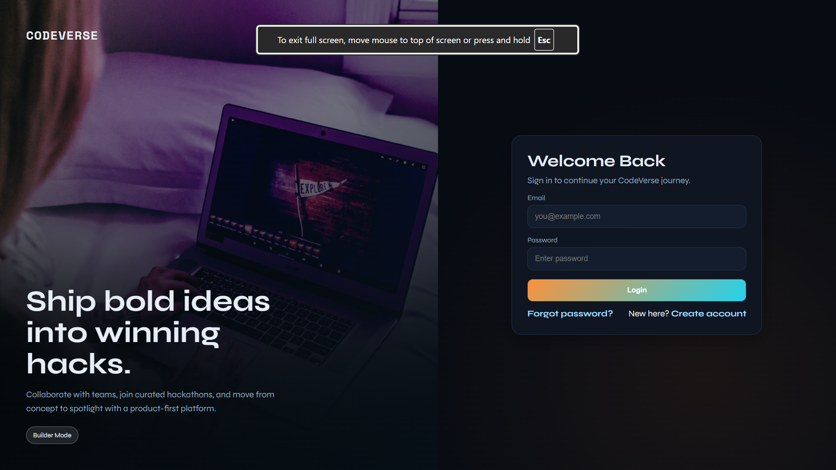

Dashboard:

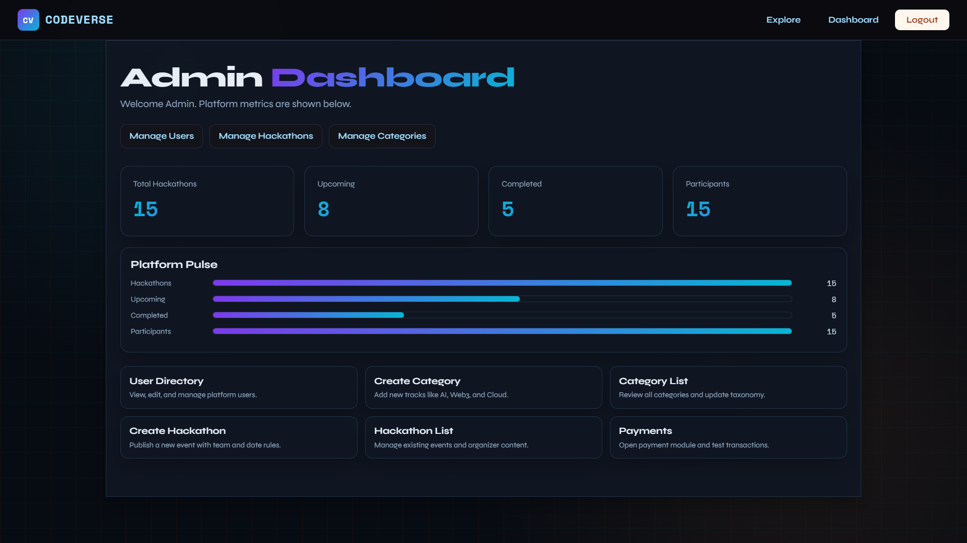

Participant Side

Explore Session



Apply with Team

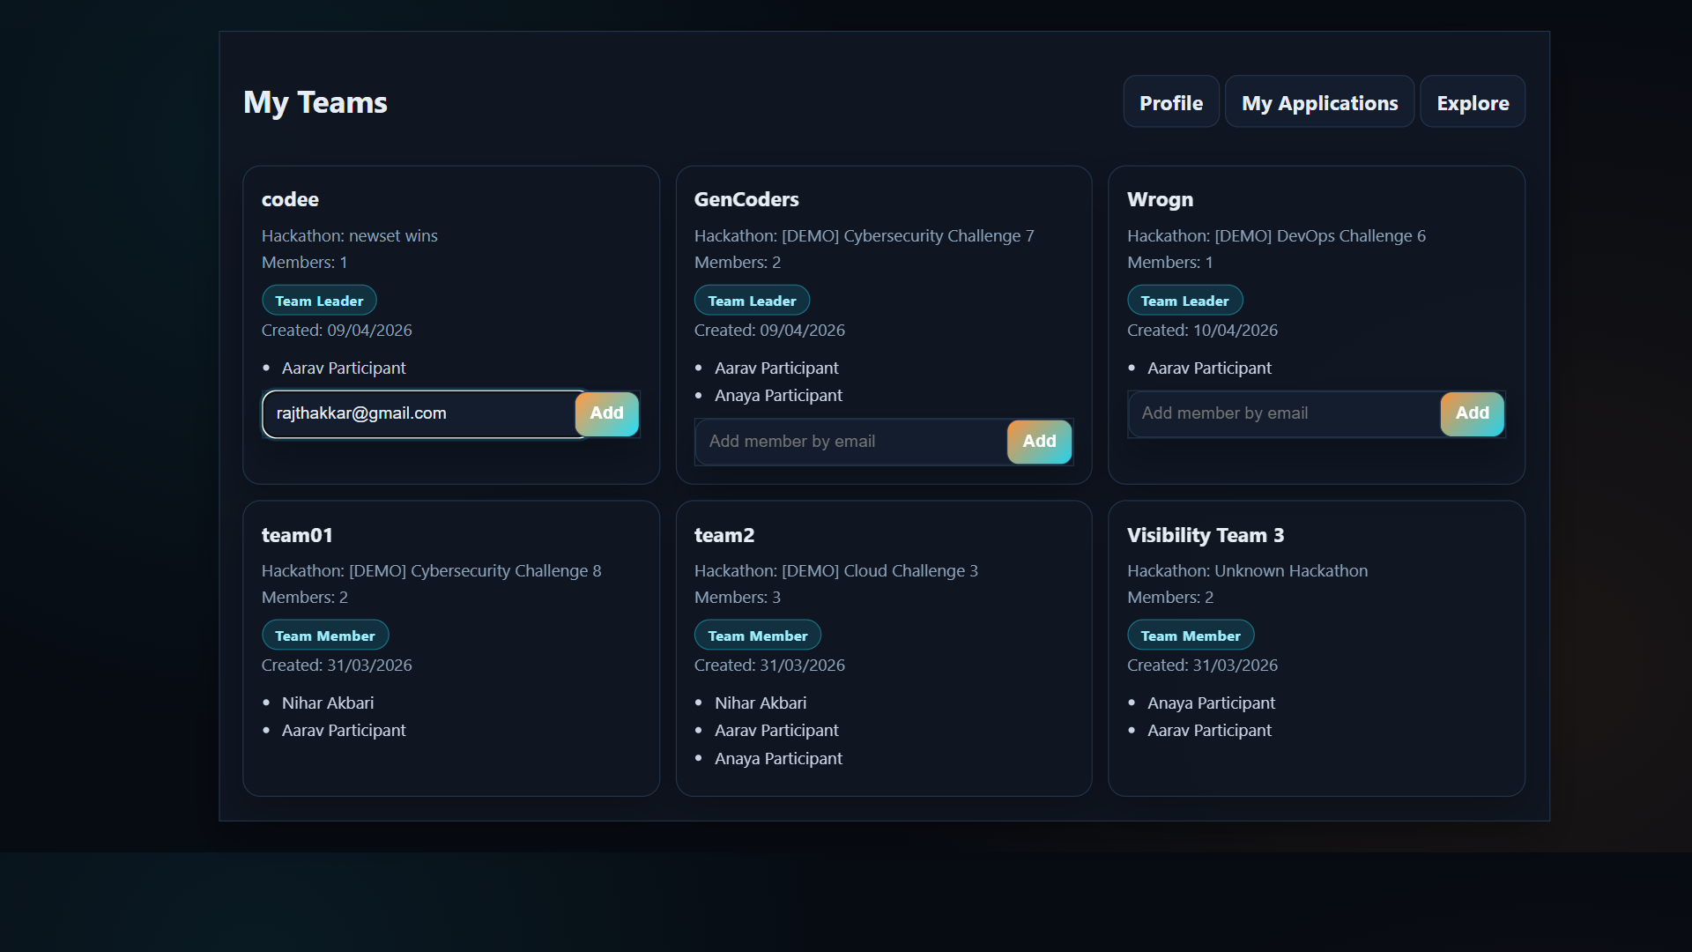

Submission

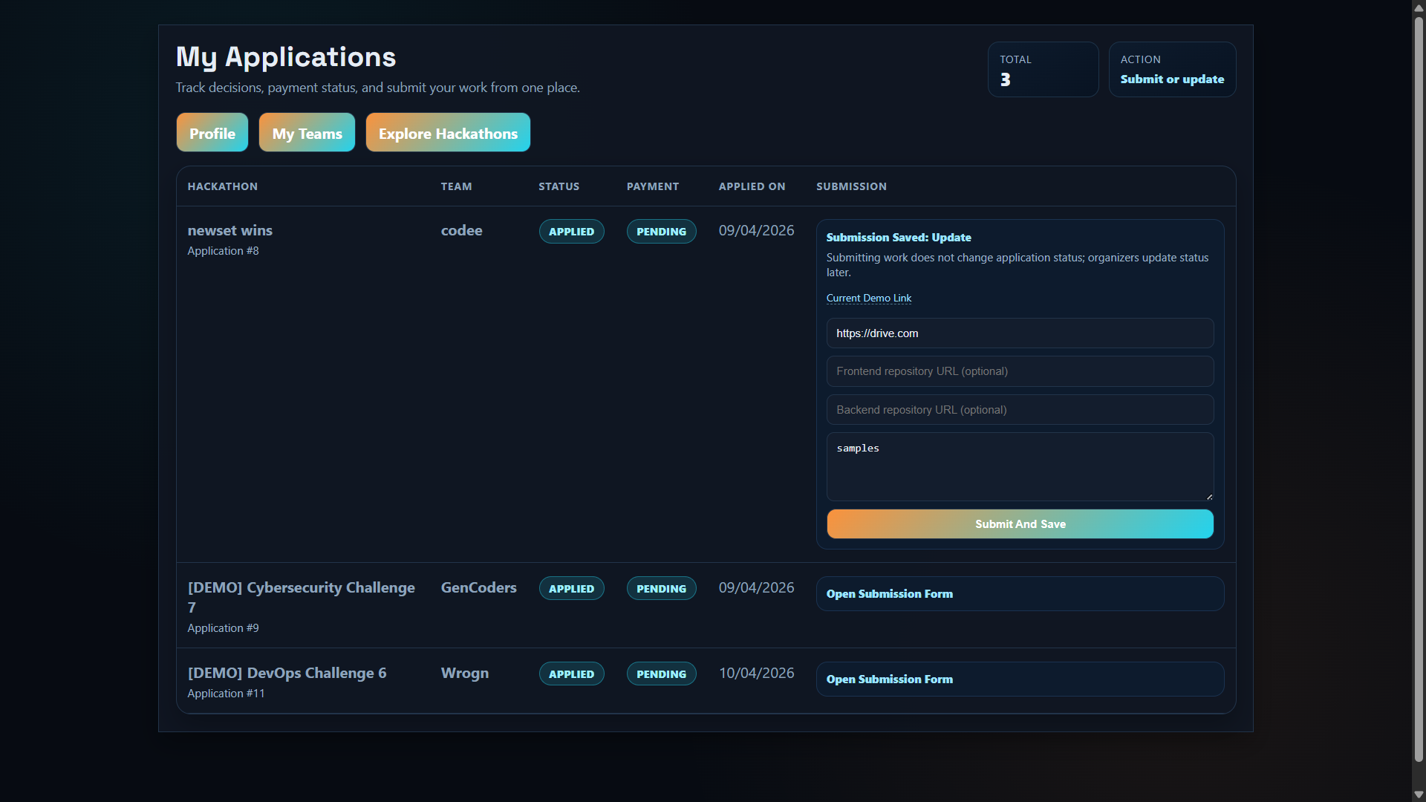

Organizer Side
- Create Hackathon
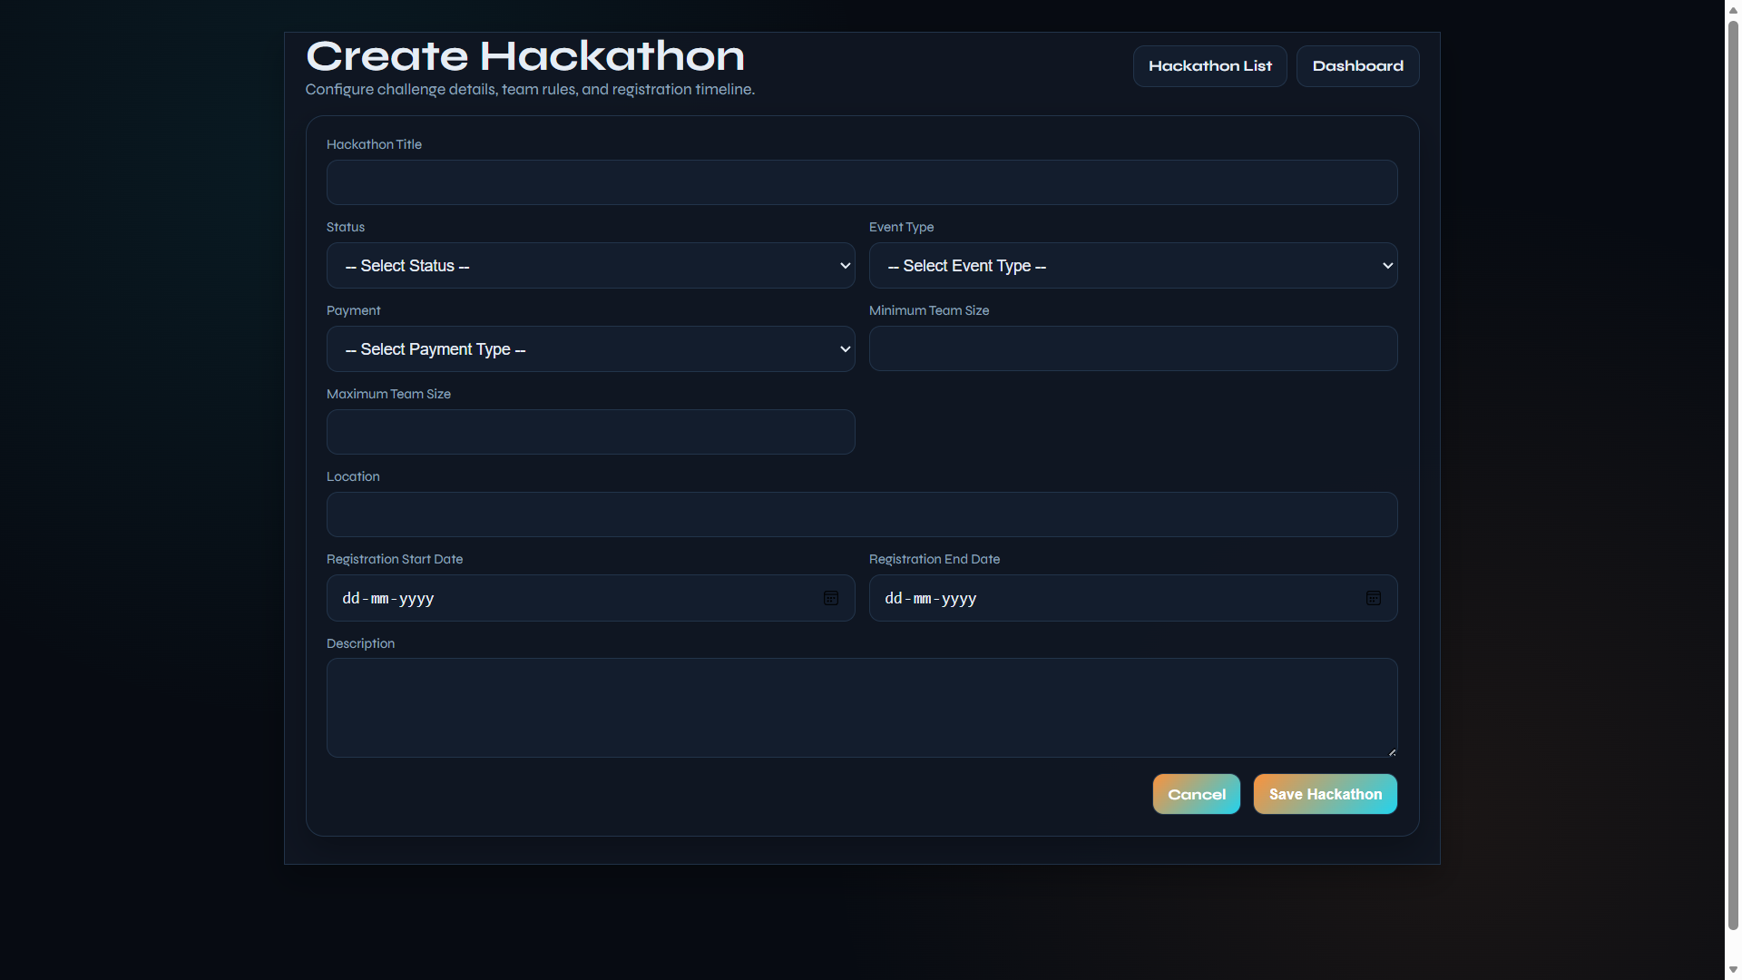
- Assign Judge
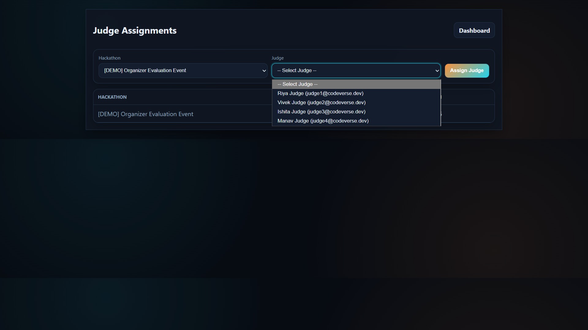

  - Judge Side:
- Judge Scoring
